頭條新聞

Headlines

在這個專案裡，你會訓練電腦認得不同報紙的頭條新聞風格。

In this project, you will train a computer to recognise headlines from different newspapers.

你會從不同的報紙裡蒐集頭條新聞，並利用這些頭條來訓練一個機器學習模型。這個模型將能從頭條的用字風格認出他是來自哪一份報紙。

You will collect examples of the front-page headlines from different newspapers. You’ll use those to train a machine learning model that can learn from the use of language to be able to recognise which newspaper a headline is from.



This project worksheet is licensed under a Creative Commons Attribution Non-Commercial Share-Alike License

http://creativecommons.org/licenses/by-nc-sa/4.0/

1. 搜尋網頁：<https://machinelearningforkids.co.uk/>

Go to <https://machinelearningforkids.co.uk/> in a web browser

1. 點選“**Get started**”按鈕

Click on “**Get started**”

1. 點選“**Log In**”按鈕並登入系統

*如果你沒有帳號，請你的老師或組長幫忙。*

Click on “**Log In**” and type in your username and password  
*If you don’t have a username, ask your teacher or group leader.*

1. 點選上方清單中的 **”Projects”** 按鈕

Click on “**Projects**” on the top menu bar

1. 點選 “**+ Add a new project**” 按鈕

Click the **“+ Add a new project**” button.

1. 將你的專案命名為 “newspapers”並設定成辨識 “**text**”類別，點

選 “**Create**”按鈕

Name your project “newspapers” and set it to learn how to recognise “**text**”. Click “**Create**”  
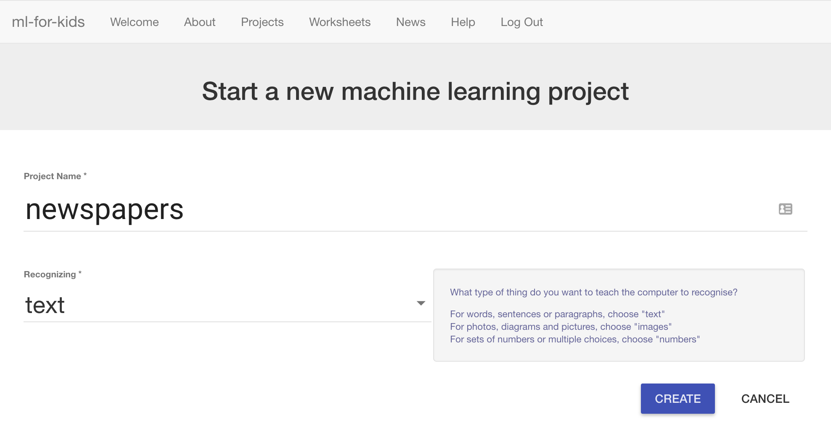

1. 你會在專案清單中看到“**newspapers**”，點選此專案

You should now see “newspapers” in your projects list. Click on it.  
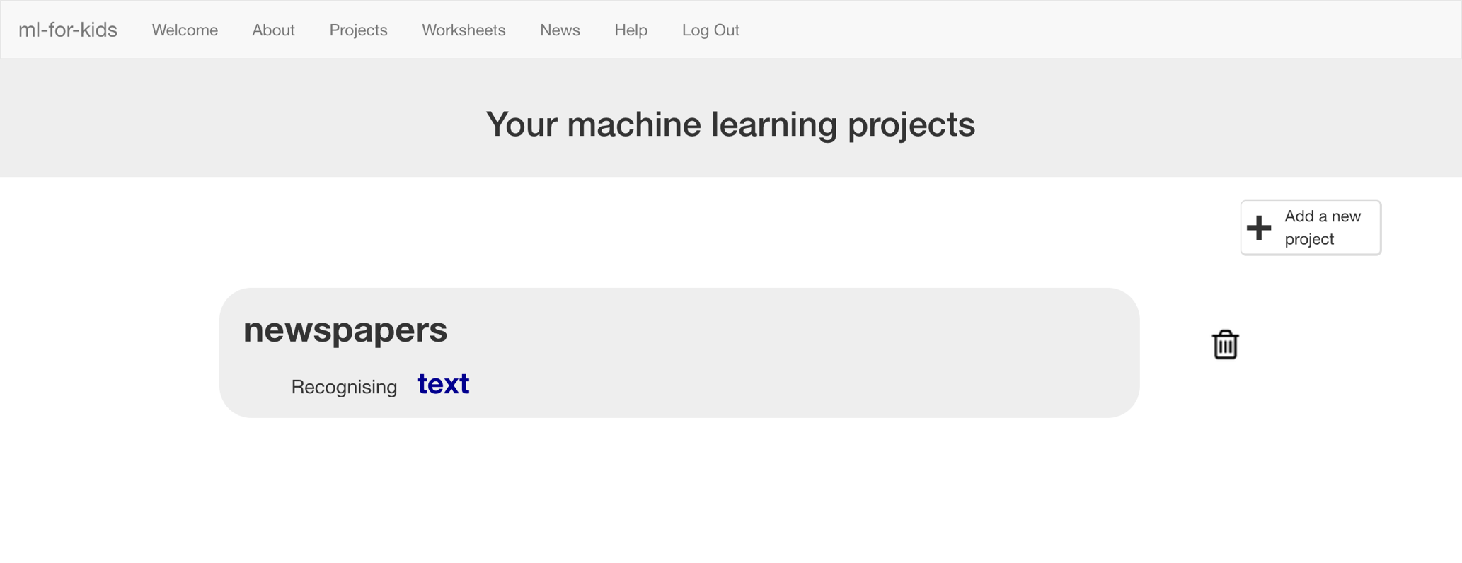

1. 點選 **”Train”** 按鈕

Click the “**Train**” button  
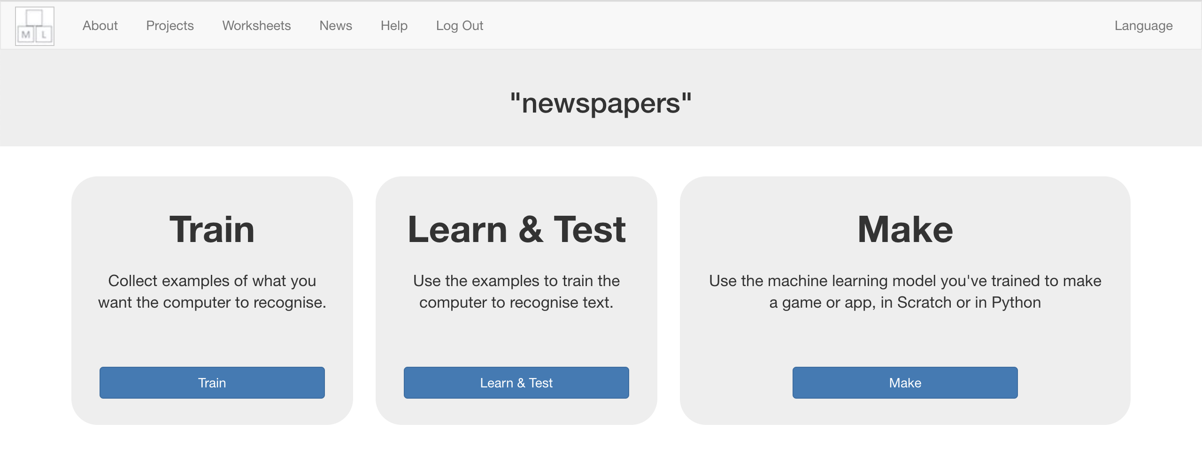

1. 挑選四份報紙

*你可以使用電子版的報紙來蒐集頭條新聞，這樣就不用去買實體報紙了*

*在這份學習單裡，我挑選的報紙分別是：*

*Daily Mail, Daily Telegraph, The Guardian, The Independent*

*而我從* [*https://www.thepaperboy.com/uk/front-pages.cfm*](https://www.thepaperboy.com/uk/front-pages.cfm)*搜尋頭條*

Choose four national newspapers.   
*To save having to buy actual physical newspapers, you can use an online collection of newspaper front pages.   
  
For the rest of this worksheet, I’ll be using:   
 Daily Mail, Daily Telegraph, The Guardian, The Independent  
and getting the headlines from:* [*https://www.thepaperboy.com/uk/front-pages.cfm*](https://www.thepaperboy.com/uk/front-pages.cfm)

1. 點選 “**+ Add new label**”按鈕並幫你選的四份報紙各自建立一個框框

Use the “**+ Add new label**” button to create a bucket for each newspaper you’re using.  
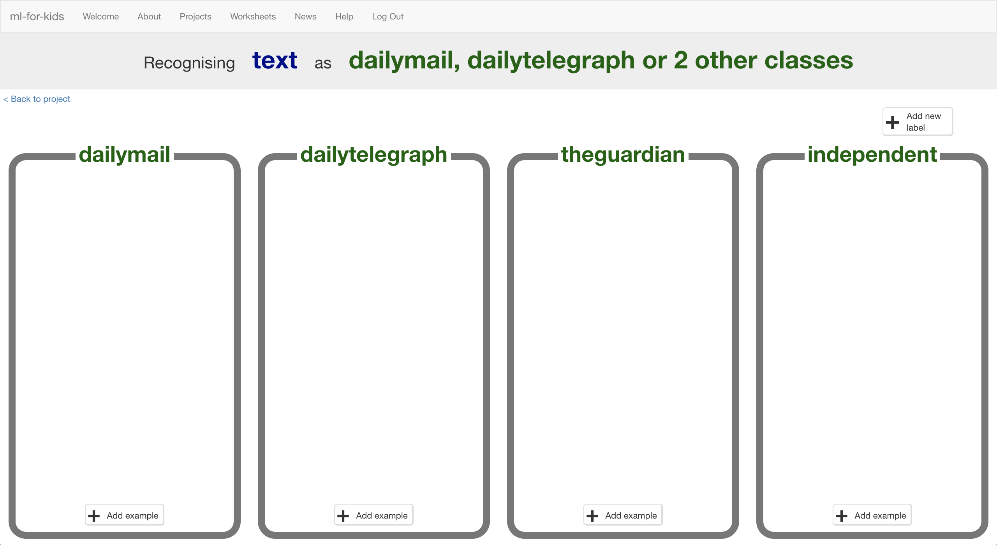

1. 在另一個網頁視窗中搜尋新聞頭條

調整視窗（如下圖）

In another web browser window, find newspaper front pages.  
*Arrange the windows so your training buckets are next to the book site.*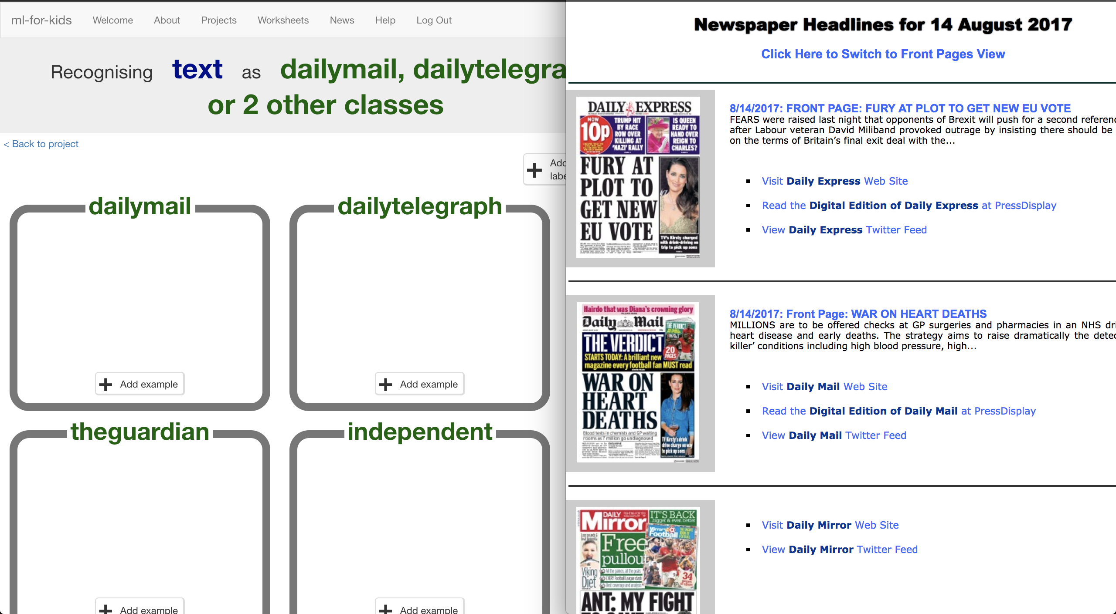

1. 為了讓訓練能更一致，定一些蒐集標題的規則吧！

*在這份學習單中，我使用的規則是：*

*\*只採用週間（週一至週五）的報紙，假日的不採用*

*\*只採用每份報紙最大的頭條新聞*

Agree on some rules for the examples of headlines that you’ll collect, so that the training is consistent.   
*For the rest of this worksheet, I’ll be using:   
* Newspapers from weekdays only (Mon-Fri) not weekend editions  
* Only the biggest main headline from each newspaper*

1. 點選其中一個方框中的“**+ Add example**”按鈕，在“Add new example”的方框中貼上報紙的新聞標題

Click the “**+ Add example**” button in one of the buckets and copy the newspaper headline into the “Add new example” dialog.   
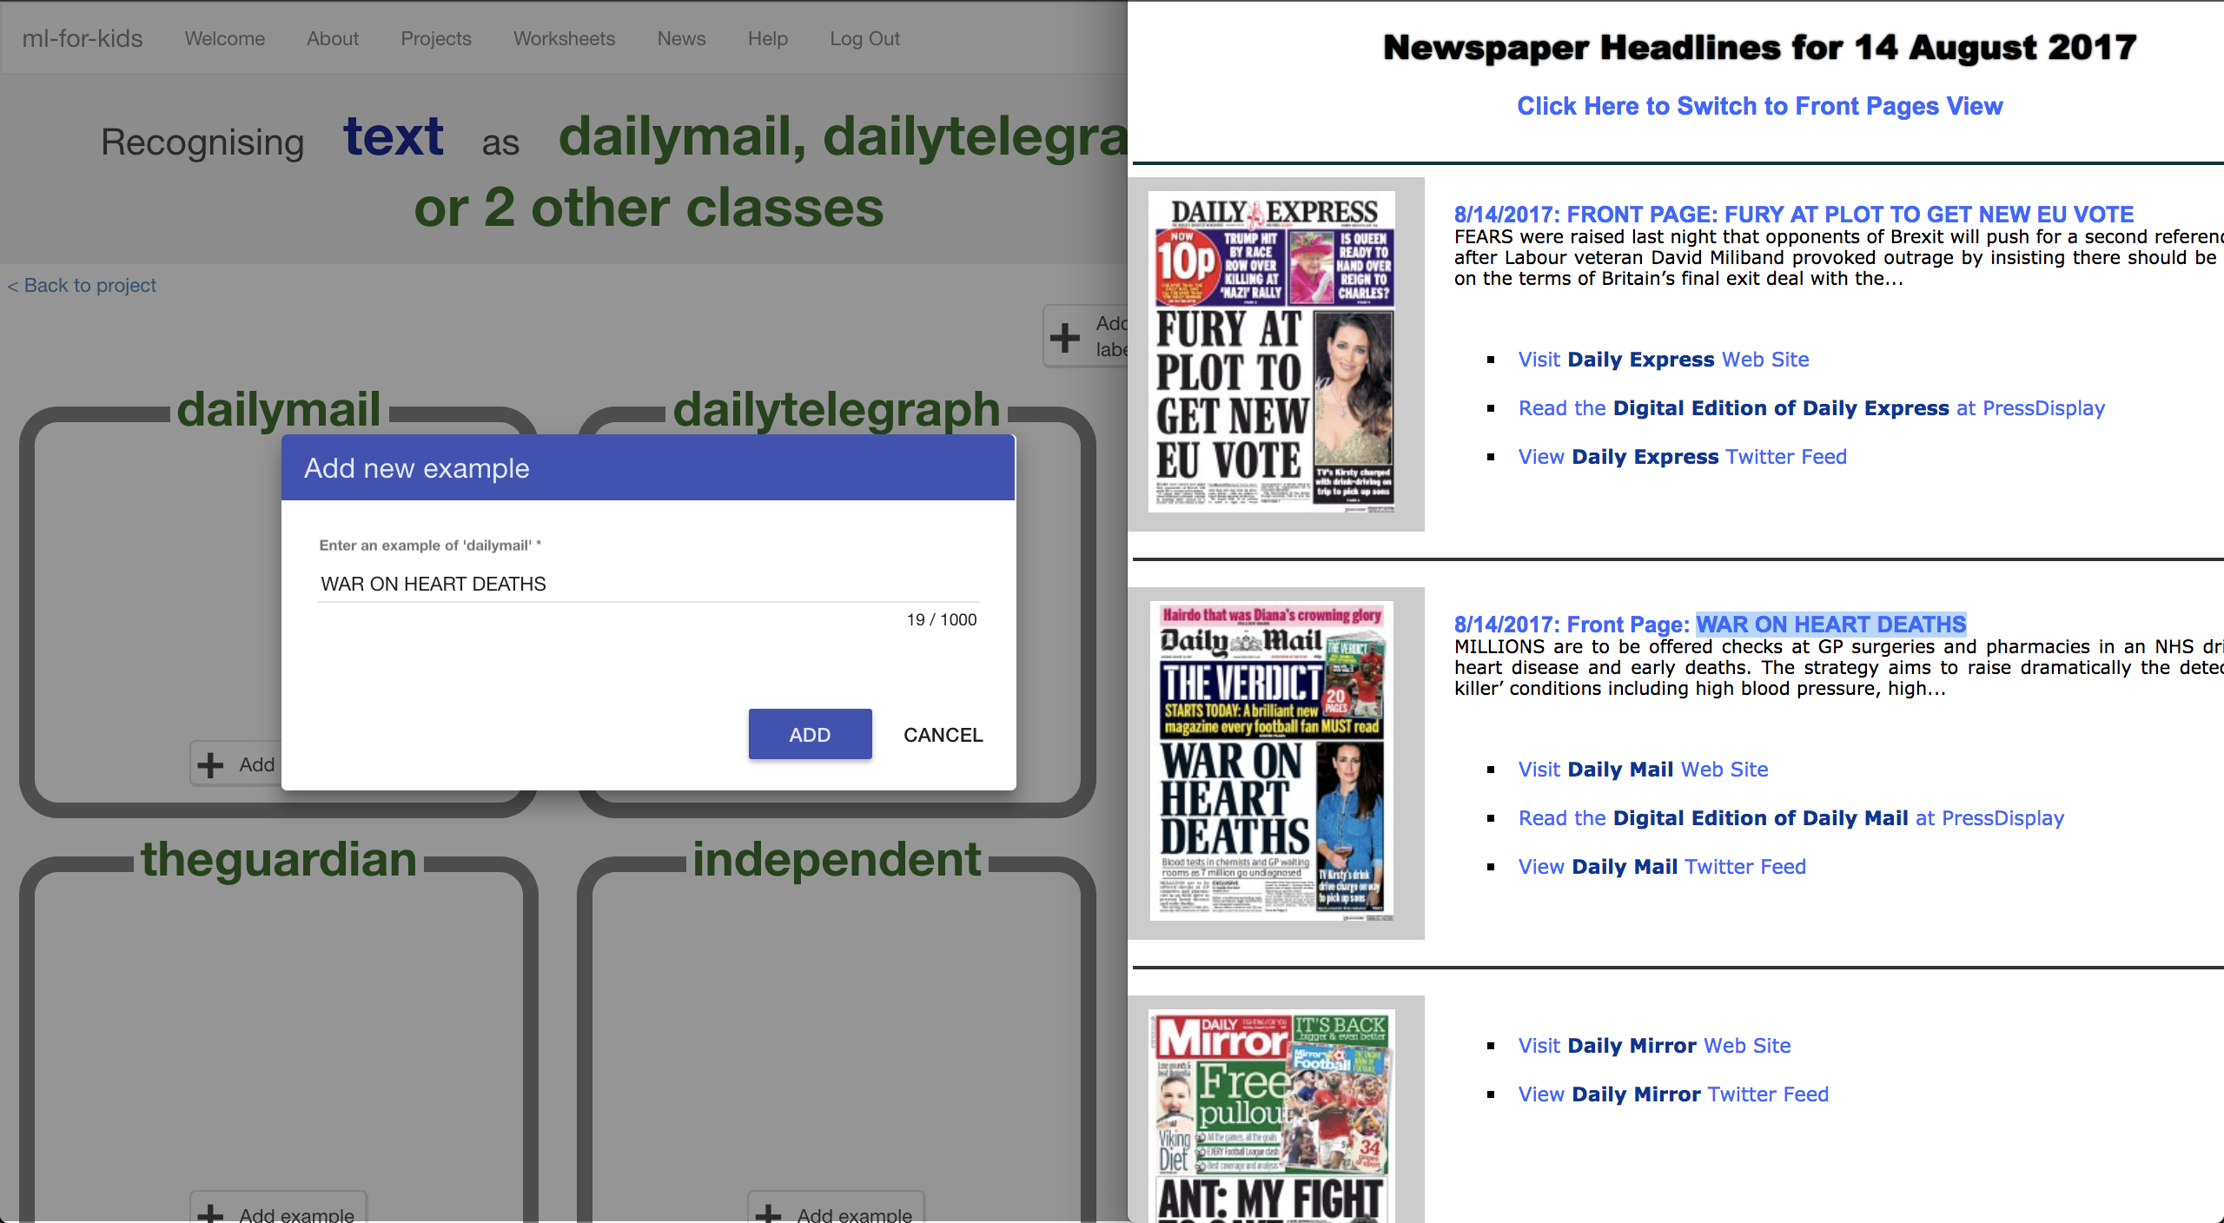

1. 重複上述步驟，將四份同天報紙的頭條標題都加入各自的方框中

Repeat this for all four newspapers on this day  
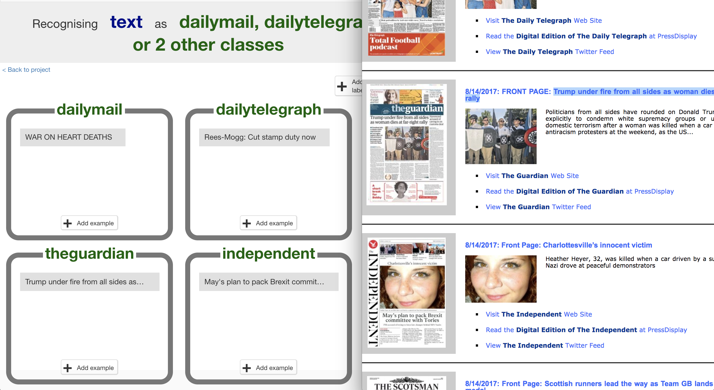

1. 重複這個動作，直到你在方框中加入了五天的頭條標題。

Repeat this for five days of newspaper headlines.   
*If you’re using front pages from thepaperboy.com you can use the calendar at the bottom of the page to switch to a different day.  
Remember the rules: Weekdays only. Biggest headline you see.  
Tip: Use the ‘Front Page Headline View’ to get headlines as text.*

1. 現在你已經有一週的範例了。保留剛搜尋新聞的視窗，晚點還會用到。

You should now have examples from one week of newspapers  
*Keep the newspaper site window open – you’ll need it again later.*  


1. 點選“**< Back to project**”，再點選“**Learn & Train**”

Click the “**< Back to project**” link. Then click “**Learn & Train**”

1. 點選“**Train new machine learning model**”

Click “**Train new machine learning model**”.  
*一旦你蒐集到夠多範例，電腦就可以開始從範例中學習辨別頭條新聞*

*As long as you’ve collected enough examples, the computer should start to learn how to recognise headlines from the examples you’ve given to it.*

1. 等待訓練完成，這可能需要幾分鐘的時間。

Wait for the training to complete. This might take a few minutes.

1. 在**Test**的方格中輸入一個頭條來測試

Try the model out by putting a headline into the **Test** box  
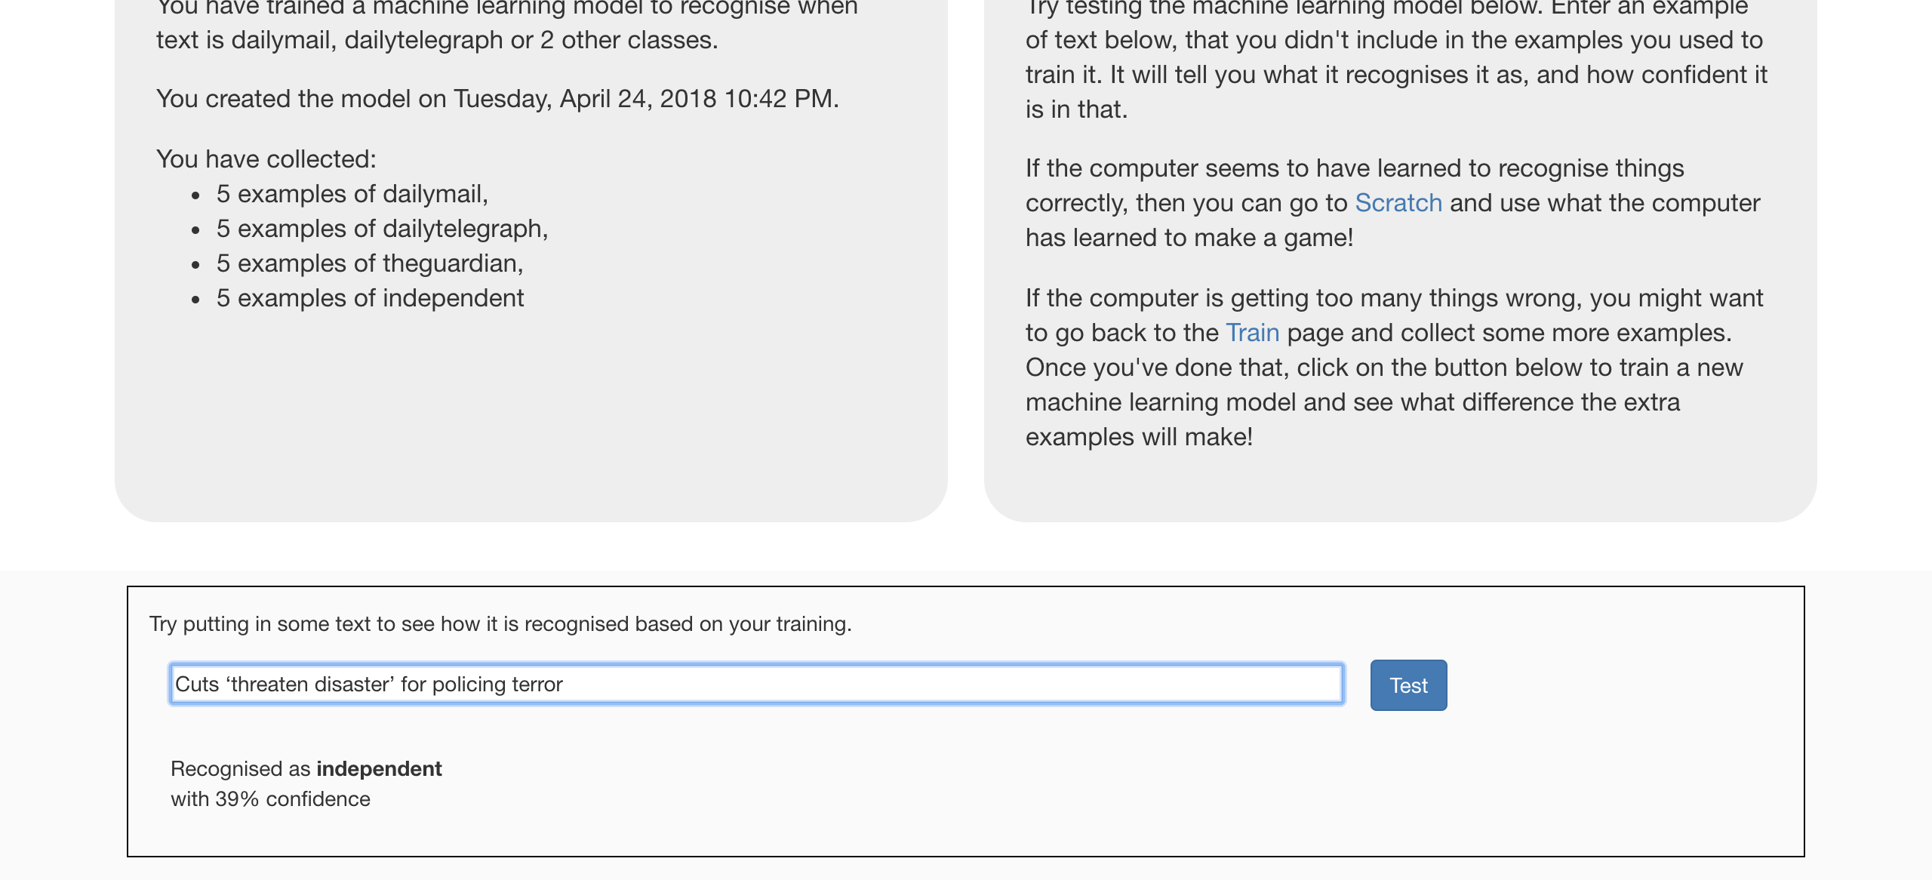

1. 點選“**< Back to project**”

Click the “**< Back to project**” link

**到目前為止，你做了哪些事情？**

**What have you done so far?**

你已經開始訓練一個機器學習模型，從不同份報紙在頭條標題的遣詞用字、標點符號使用上尋找共通的模式。

You’ve started to train a machine learning model to recognise patterns in the way that different newspapers use words, phrasing and punctuation in their front-page headlines.

但這能成功嗎？電腦到目前學到多少了？需要更多範例來提高正確性嗎？模型擅長或不擅長什麼？模型在辨識哪些報紙時容易搞混？

But is it working well? How much has it learned so far? Does it need more examples to be able to recognise headlines correctly?  
What is it good at? What is it bad at? Which newspapers does it get confused between?

1. 點選“**Make**”按鈕，然後點選“**Scratch**”按鈕

Click the “**Make**” button, then click the “**Scratch**” button

1. 點選“**Open in Scratch**”

Click the “**Open in Scratch**” button  
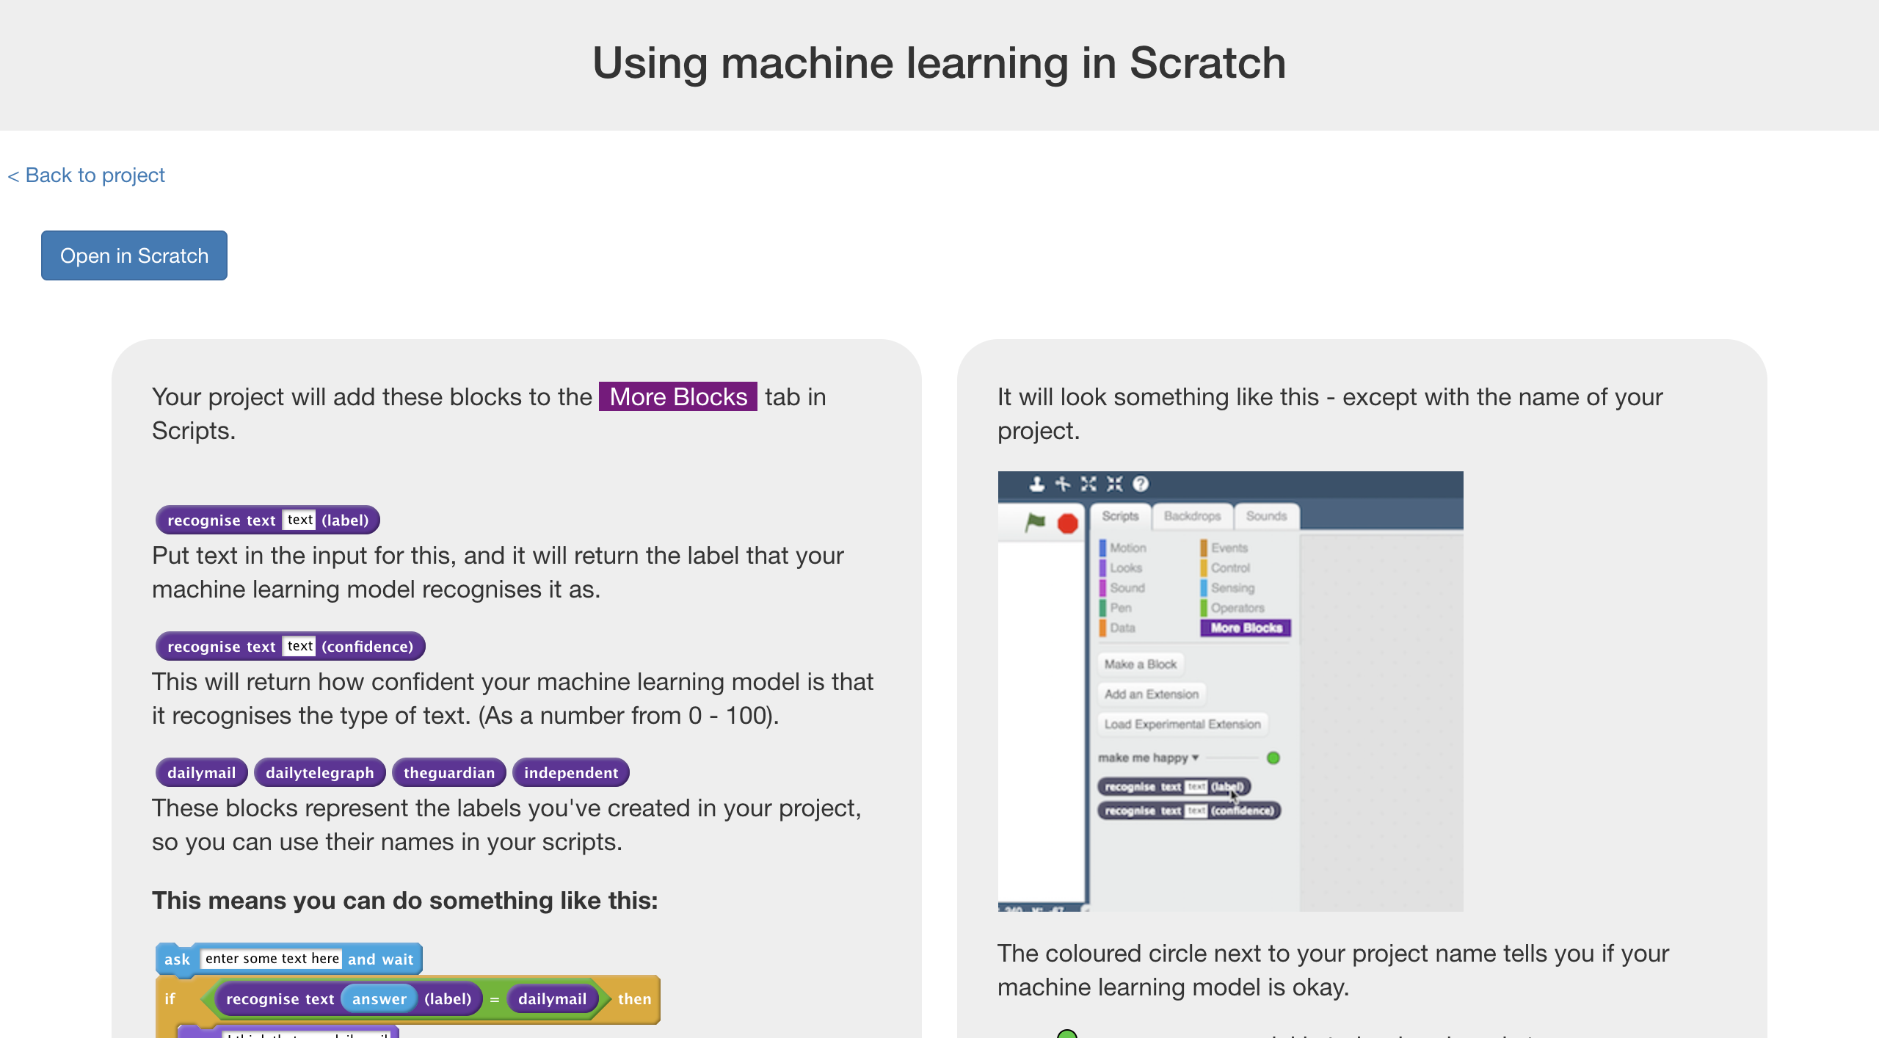

1. 你會在專案裡的『更多積木』(More blocks)區看到新積木

*You should see blocks in “More blocks” section from your project.*  
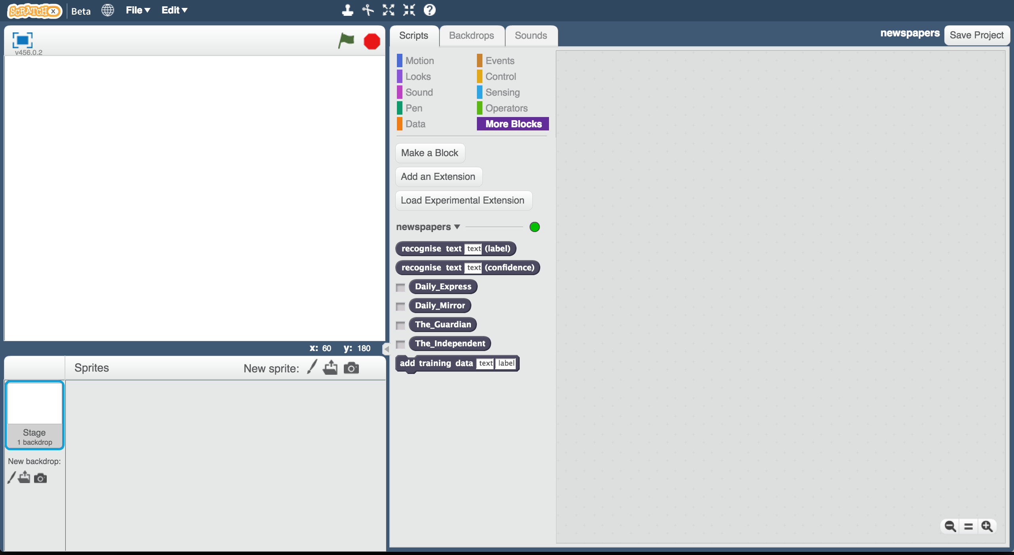

1. 點選『舞台』，然後點選『背景』

Click on the Stage, and then click on the Backdrops tab  
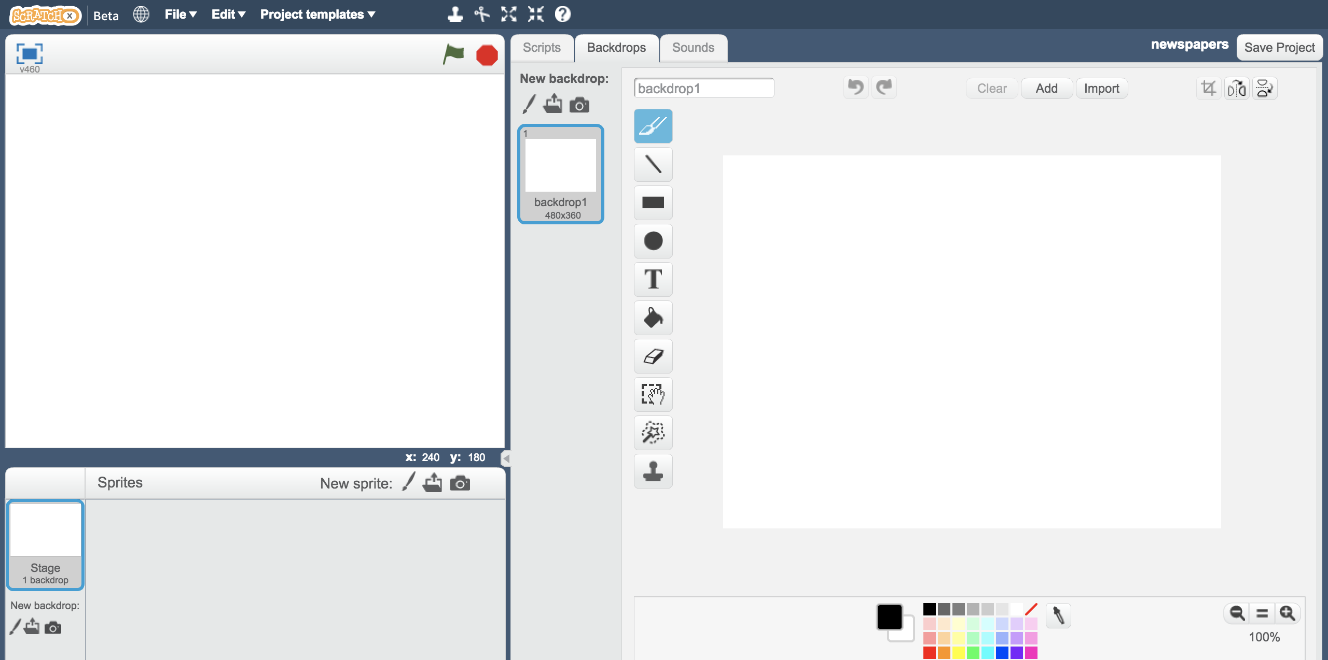

1. 為你的四份報紙畫出分隔線

Draw some shelves for your newspapers  
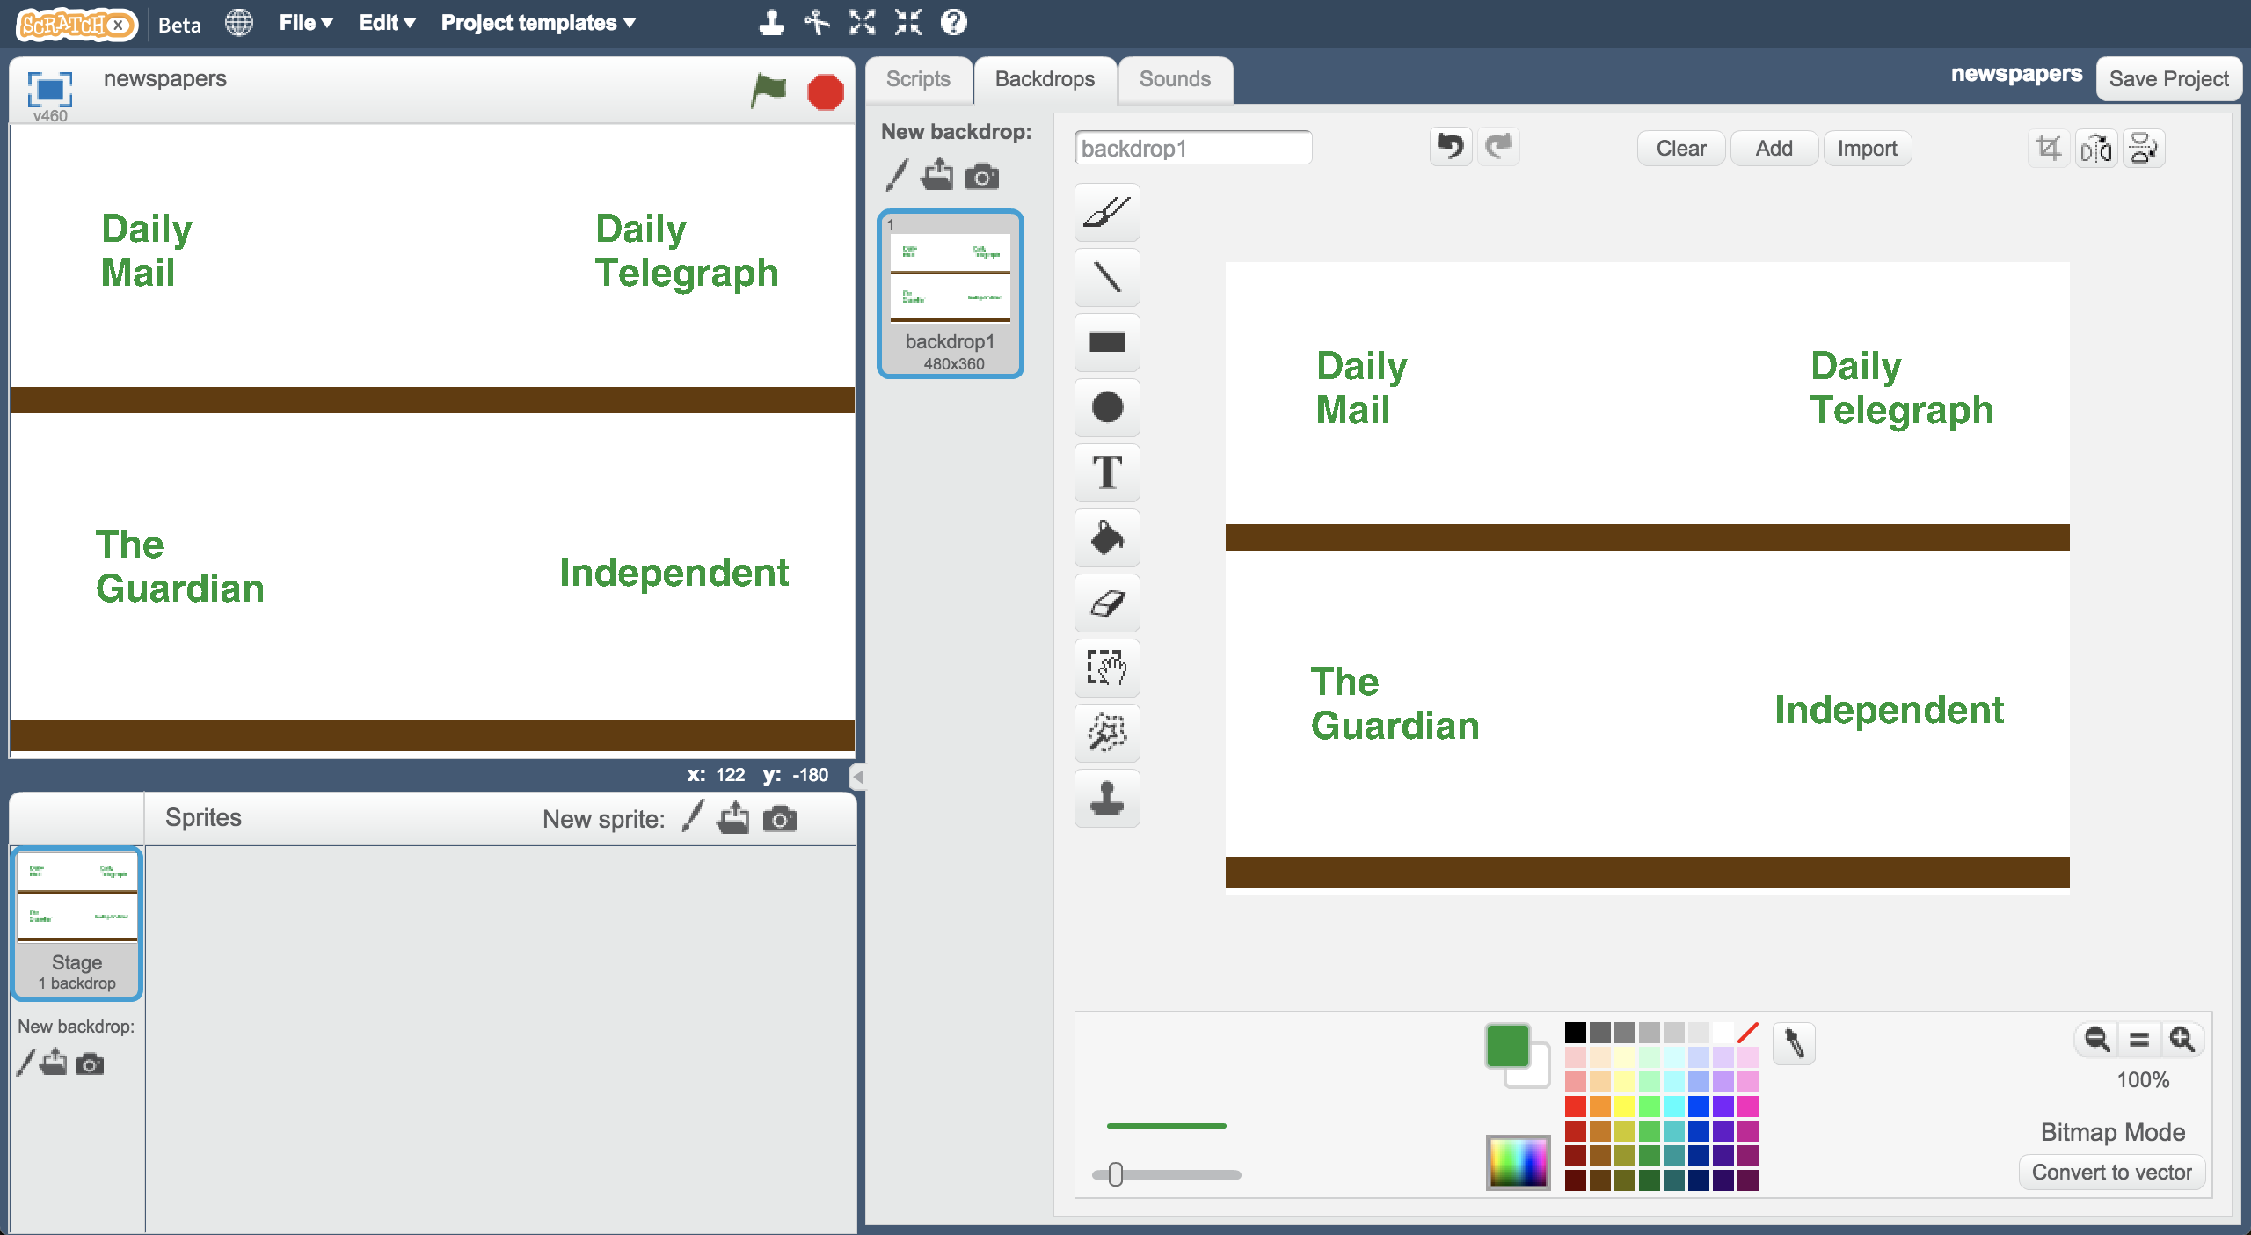

1. 點選畫筆，要畫出一個新的角色

Click on the paintbrush icon to draw a new Sprite  
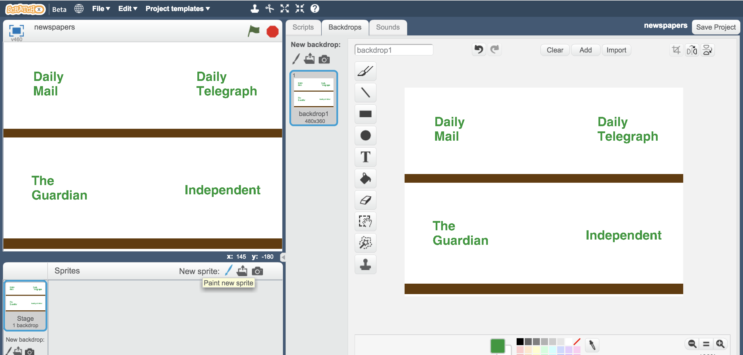

1. 畫一份簡單的報紙圖案

Draw a simple newspaper  
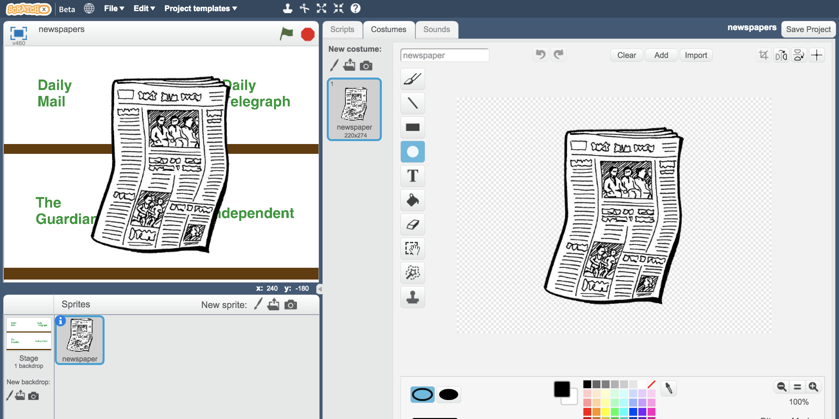

1. 拖曳程式積木（如下圖）

*當你輸入一條頭條新聞時，這份程式碼會預測新聞來自哪份報紙，並把角色放在對應的報紙區域*

Create the following script  
*When you type in a headline, this script will predict what newspaper the headline is from and put it on the right shelf.*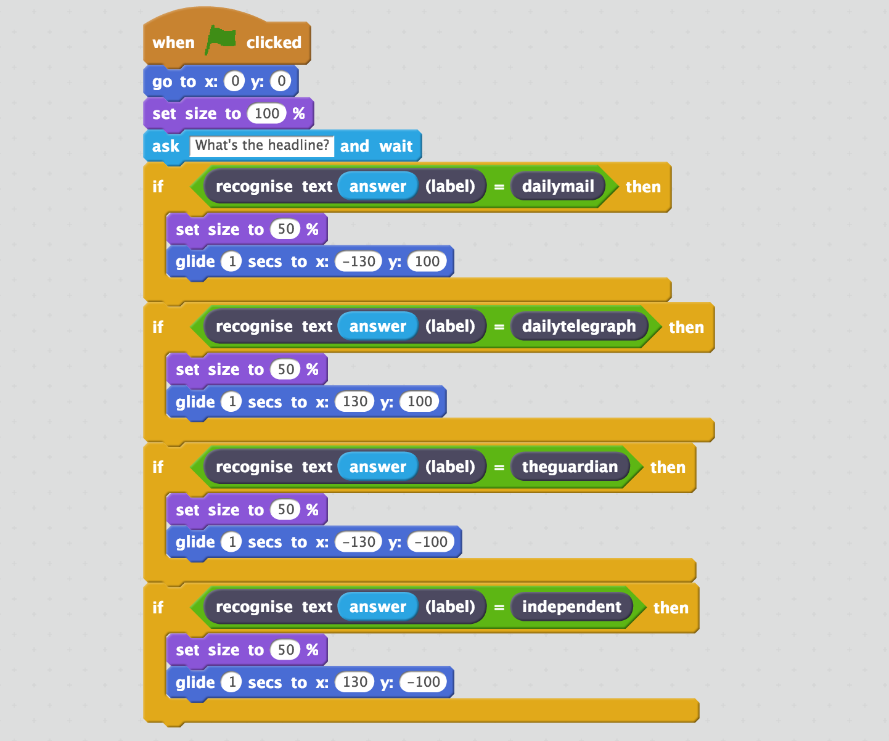

1. 點擊綠旗

Click the **Green Flag** to test  
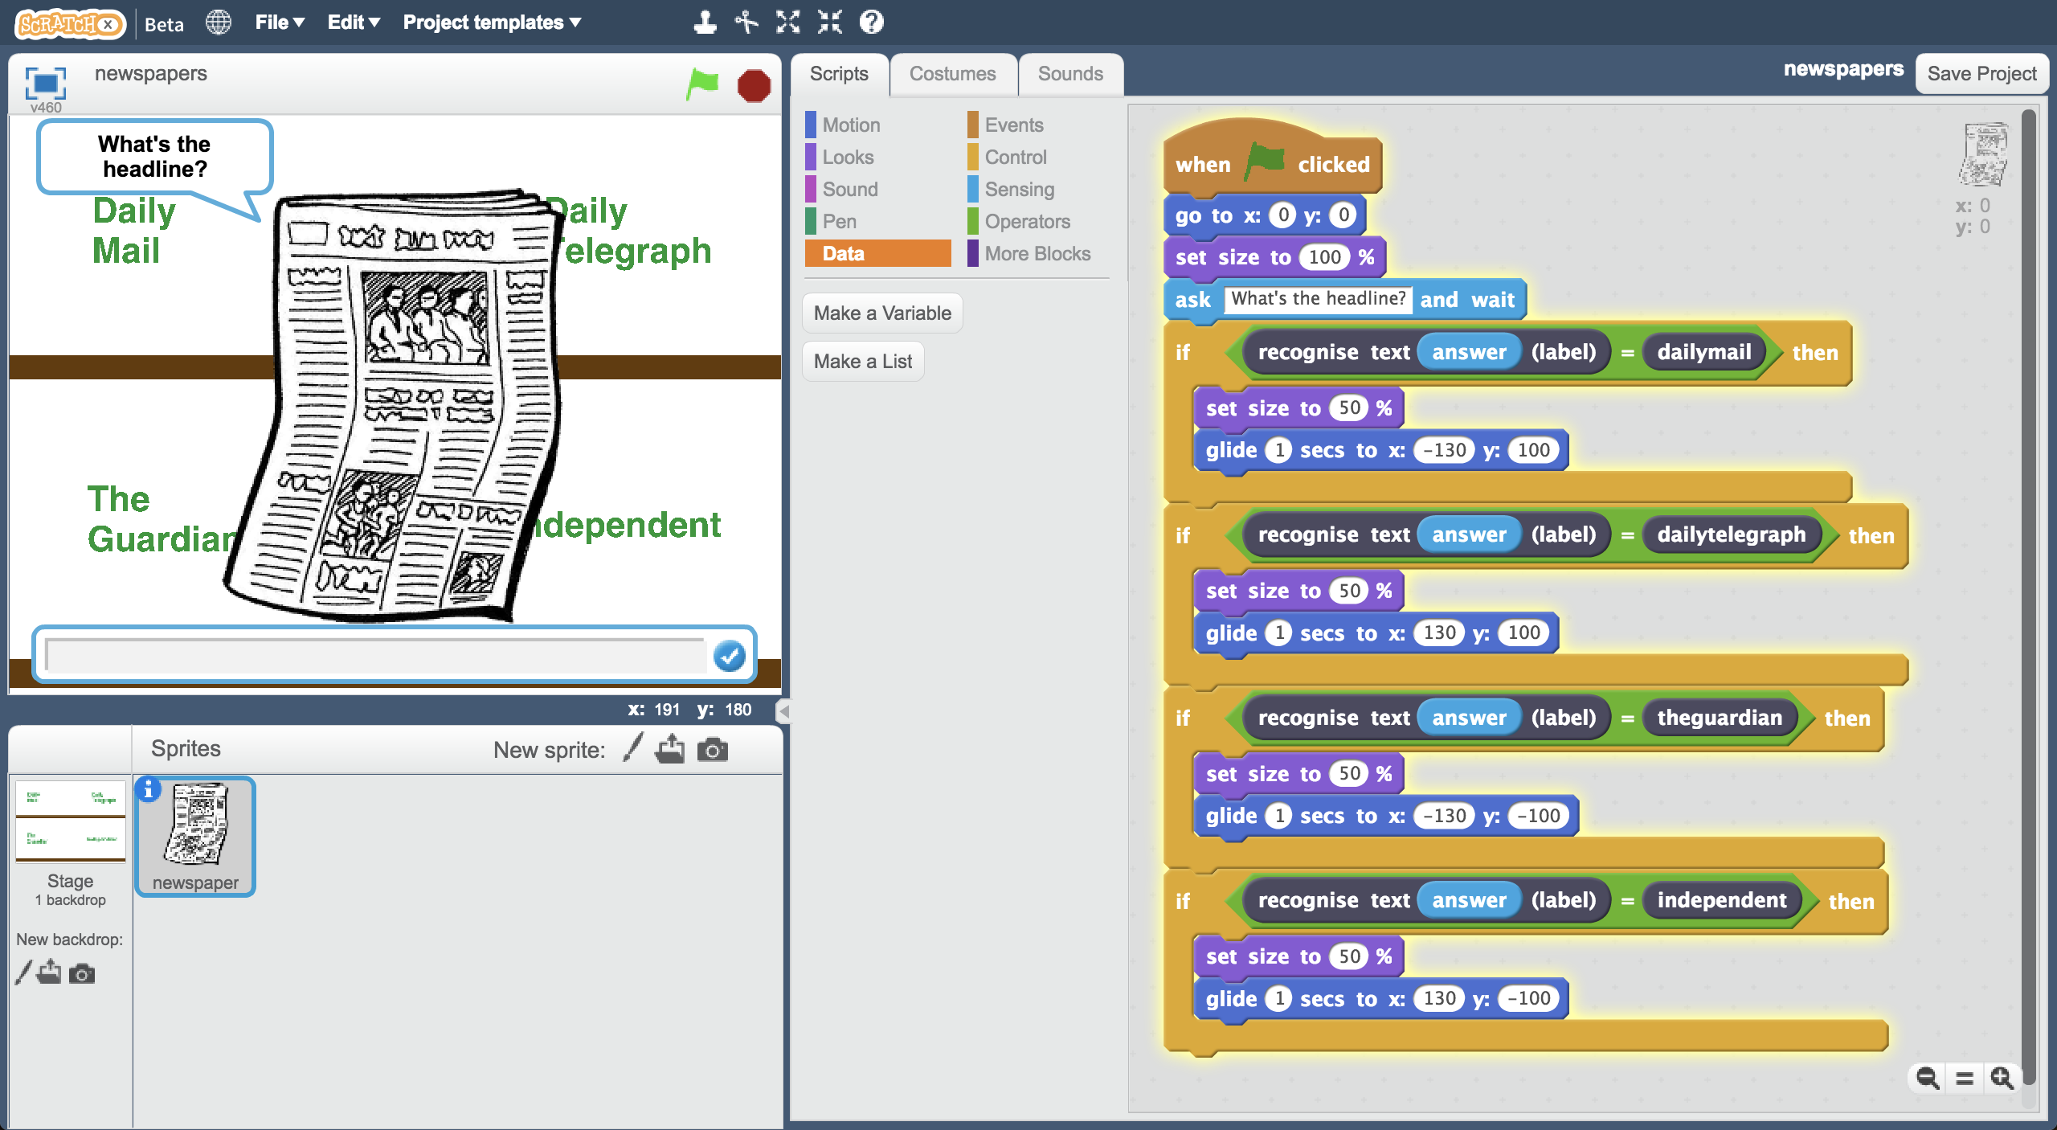

1. 試試看輸入不同頭條並觀察結果

*確認你輸入的頭條和前面用來訓練模型的沒有重複*

Try typing in different headlines and see how the computer behaves  
*Make sure you use headlines that you didn’t use to train the model*

1. 存檔

點選檔案，再點選儲存專案

Save your Scratch project  
*Click on* ***File*** *->* ***Save Project***

**到目前為止，你做了哪些事情？**

**What have you done so far?**

你訓練了一個機器學習模型來辨識報紙的頭條新聞。你只給了電腦非常少的範例（只有一週）。

You’ve started to train a machine learning model to recognise newspaper front-page headlines. You’ve given it a very small number of examples to learn from – only a single week’s worth of newspapers.

你建立了一個Scratch專案，用模型沒見過的頭條來做測試。你應該會發現模型預測結果有很多錯誤。

You’ve created a project in Scratch to test your model on headlines it hasn’t seen before. You’re probably seeing that it gets a lot wrong.

接下來要給模型更多練習以提高正確率。有了更多範例，模型應該就能判斷得更準確。  
The next step is to try and improve the results by giving our machine learning model some more training. With more examples of headlines, it will hopefully do better.

1. 回到訓練視窗

Switch back to the training window

1. 點選**“< Back to project**”

Click on the **“< Back to project**” link.

1. 點選**Train**按鈕

Click the **Train** button

1. 重複步驟13~15

*蒐集其他星期的報紙頭條，每份報紙要有15個範例頭條新聞*

Repeat steps 13-15.   
Collect additional headlines from another couple of weeks of newspapers.   
*You should now have fifteen example headlines from each newspaper.  
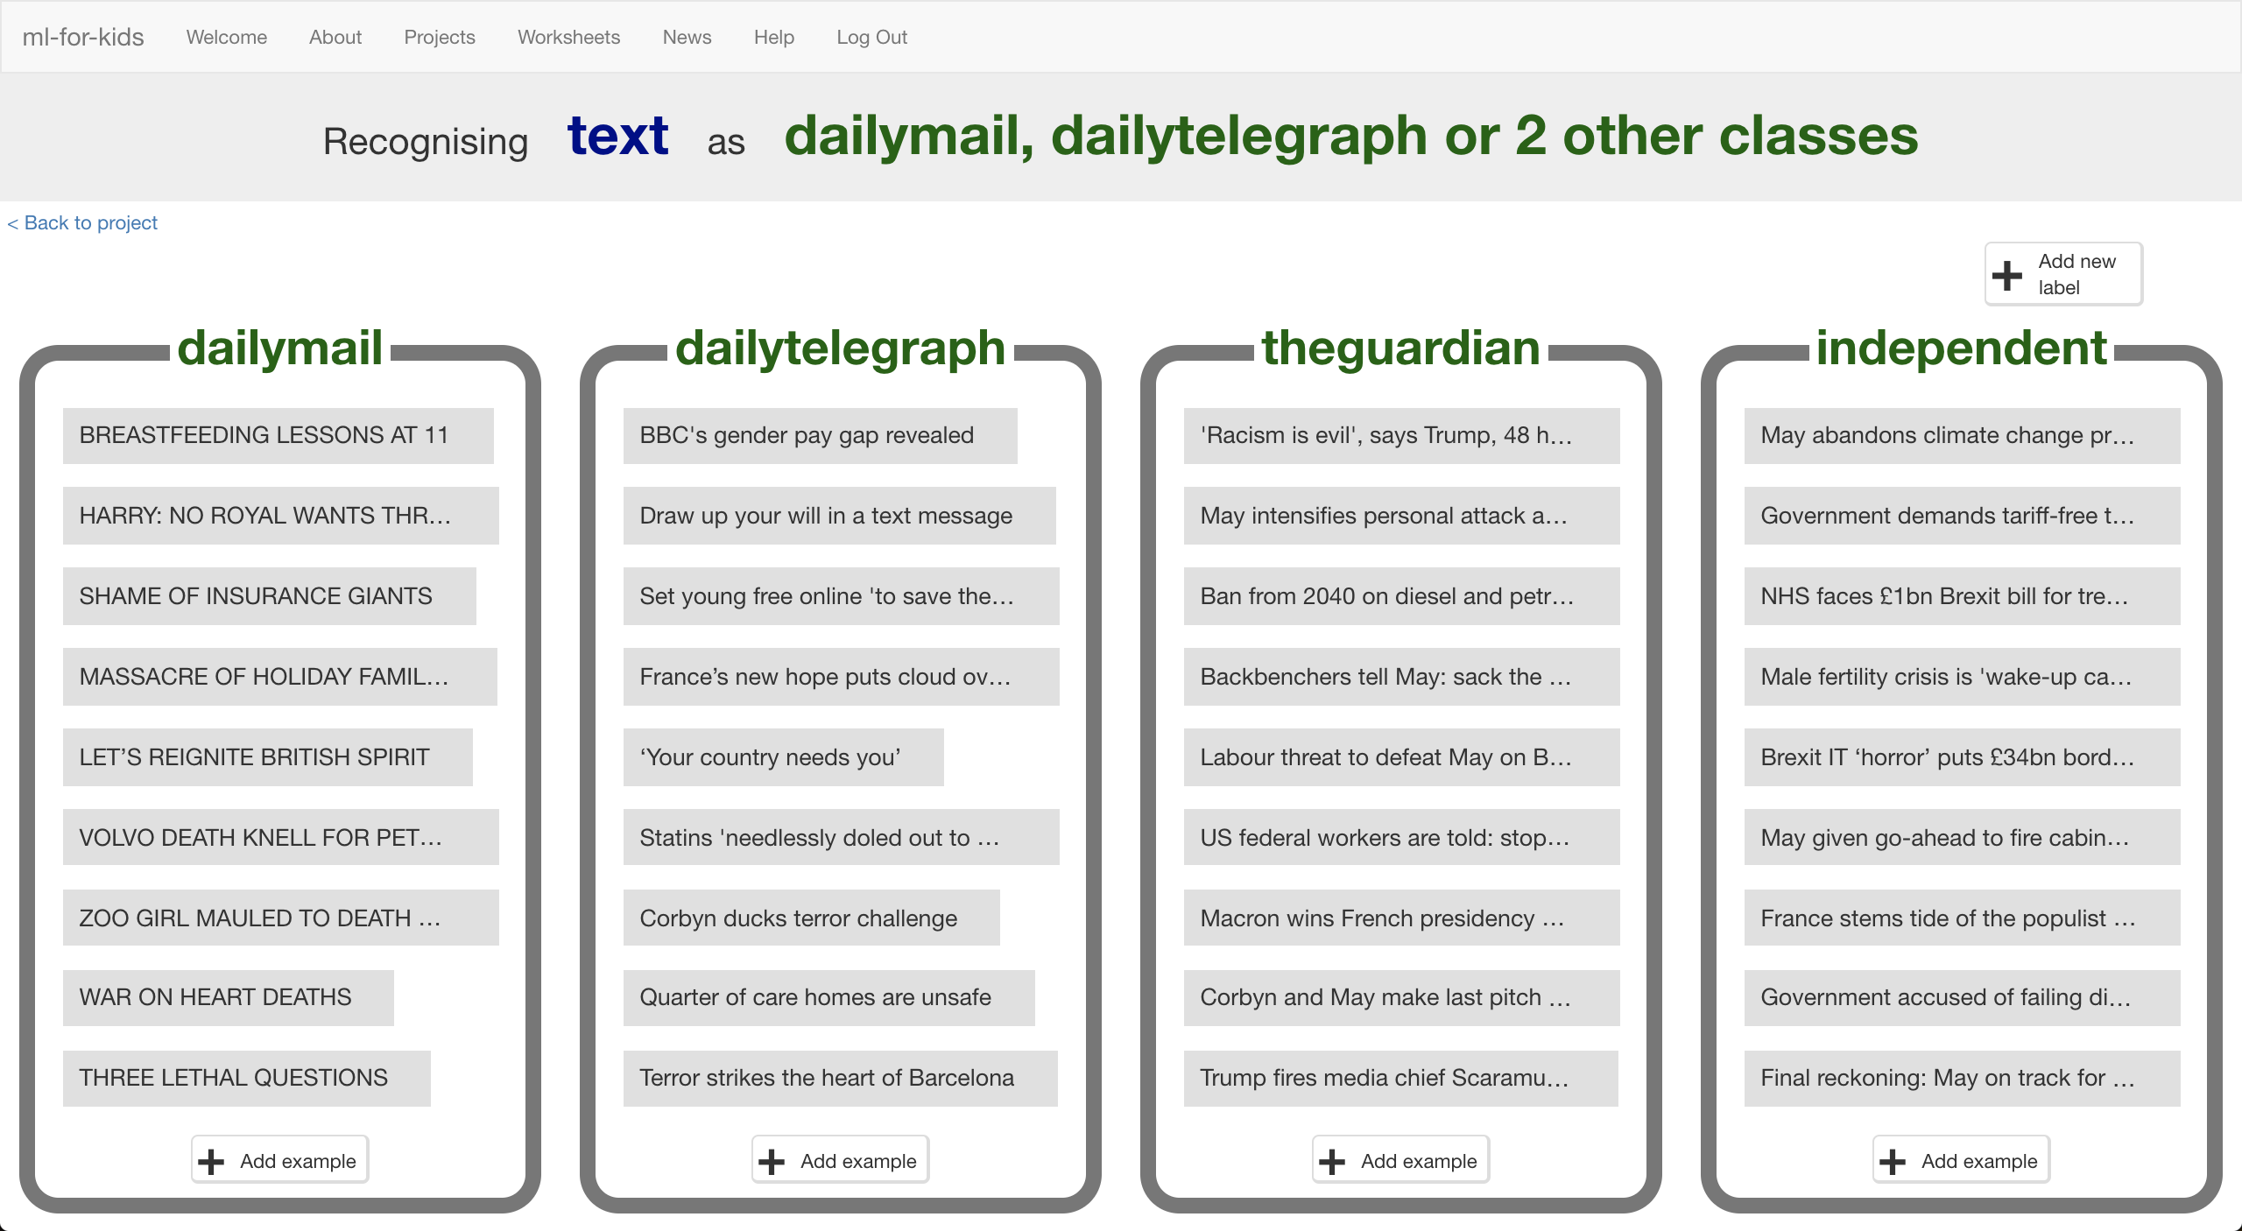*

1. 點選“**< Back to project**”，再點選**Learn & Test**按鈕

Click the “**< Back to project**” link. Click the **Learn & Test** button.

1. 點選**Train new machine learning model**按鈕

等待訓練完成，這可能需要幾分鐘的時間

Click the **Train new machine learning model** button  
*Wait for the training to complete. This might take a few minutes.*

1. 回到Scratch視窗

*如果你不小心關掉scratch，請做以下步驟：點選“****< Back to project****” -> 點選“****Make****” ->點選“****Scratch****” ->點選“****Open in Scratch”*** *-> 點選“****File****”-> 點選“****Load Project****”，選擇先前儲存的專案*

Switch back to the Scratch window.   
*If you accidentally closed it, you can get back to it by doing this:  
* Click the “****< Back to project****” link  
* Click the “****Make****” button  
* Click the “****Scratch****” button  
* Click the “****Open in Scratch****” button  
* Open the Scratch project you saved before, with “****File****” -> “****Load Project****”*

1. 重複步驟28~29

*觀察新模型，有哪份報紙在新模型的預測結果出現的次數比在舊模型出現的次數高嗎？*

Repeat steps 28 – 29 again.   
*See how your new model is doing.  
Does your model predict which newspaper a headline comes from more often than before?*

**你完成些什麼？**

**What have you done?**

你訓練了一個機器學習模型，從四份報紙中辨識頭條新聞的語言風格。

You’ve trained a machine learning model to recognise the use of language in the front page headlines of four national newspapers.

你進行了一些測試以評估模型的執行正確度

You’ve tested the model to assess the performance of the machine learning model.

你持續對模型進行訓練，並觀察模型如何進步

You checked this at various stages of your model’s training to see how the performance improved as you continued to train it.

**延伸活動**

**Ideas and Extensions**

現在你已經完成了這個專案，要不要試試下面這些點子？或者想出其他點子？

Now that you’ve finished, why not give one of these ideas a try?

Or come up with one of your own?

**尋找報紙裡的其他共通模式**

**Look for other patterns in newspapers**

不要只比較這怎翻啊，試試看其他方式

Instead of comparing tabloid papers with broadsheet newspapers, try some other project ideas.

這感覺不適用於台灣？

What about comparing local newspapers with national newspapers? Or weekend editions with week day papers?

**試試不同數量的報紙**

**Try different numbers of newspapers**

當你加入新的報紙時會發生什麼事？模型正確率依然很高嗎？

如果你只採用兩種報紙呢？預測結果會比四種的好嗎？

What happens if you add additional newspapers? Is it still as good? What happens if you remove some, and only train it to tell headlines from two newspapers? Does it do better then?

**使用新聞的內容**

**Use newspaper stories instead of headlines**

如果不使用標題，改使用新聞的內文呢？

你可以訓練一個辨識內容撰寫風格的機器學習模型嗎？

What about the text of newspaper stories instead of headlines? Can you train a machine learning model to recognise the style of writing in the story?